This document outlines the data and methodology used for the federal fiscal impacts of H-1B workers, for a 2023 annual estimate. The methodology is current as of 12/02/2024.

# Data Sources:

1. National Expenditures: [White House Historical Tables](https://www.whitehouse.gov/omb/budget/historical-tables/)
   1. *Table 3.2 - OUTLAYS BY FUNCTION AND SUBFUNCTION: 1962 - 2029*
2. National Revenues: [White House Historical Tables](https://www.whitehouse.gov/omb/budget/historical-tables/),
   1. Income taxes and corporate taxes from *Table 2.1 - RECEIPTS BY SOURCE: 1934 - 2029*
3. [BEA Table 3.2. Federal Government Current Receipts and Expenditures](https://apps.bea.gov/iTable/?reqid=19&step=3&isuri=1&nipa_table_list=87&categories=survey) for excise tax totals.​​
4. Income Tax Brackets:
   1. [Tax Foundation 2023 Tax Brackets](https://taxfoundation.org/data/all/federal/2023-tax-brackets/)
5. U.S. Population Estimates:
   1. [Census National Estimates of the U.S. Population](https://www.census.gov/data/datasets/time-series/demo/popest/2020s-national-total.html) - (NST-EST2023-POP)
6. U.S. labor force size, mean and median income for all workers:
   1. [Occupational Employment and Wage Statistics](https://www.bls.gov/oes/2022/may/oes_nat.htm). Download the .xlsx version for median and average annual income.
7. H-1B Income estimates:
   1. [Department of Labor data from Prevailing Wage Test](https://www.dol.gov/agencies/eta/foreign-labor/wages) for 2023, for the 95th and 99th percentile estimates
   2. [USCIS Fiscal Year 2023 Annual Report to Congress](https://www.uscis.gov/sites/default/files/document/reports/OLA_Signed_H-1B_Characteristics_Congressional_Report_FY2023.pdf) for mean and median incomes
8. Excise tax eligible expenditures for excise tax estimates:
   1. [BLS Consumer Expenditure Survey microdata](https://www.bls.gov/cex/)
9. H-4 visas issued to spouses and children
   1. [State Department Nonimmigrant Visa Statistics](https://travel.state.gov/content/travel/en/legal/visa-law0/visa-statistics/nonimmigrant-visa-statistics.html), file “*Nonimmigrant Visas Issued by Issuing Office (Including Border Crossing Cards)*”
10. Children and spouses receiving permanent residence under EB-2 and EB-3
    1. Y[earbook of Immigration Statistics, 2022](https://ohss.dhs.gov/topics/immigration/yearbook/2022), table 7d
11. H-4 Employment authorization:
    1. [USCIS annual I-765 report](https://www.uscis.gov/sites/default/files/document/reports/i765_application_for_employment_fy03_22_annual_report.xlsx)

# Methodology:

## Scenario Probabilities

We assume that there are no single-parent H-1B households, and that children are distributed equally among working and nonworking H-1B spouses.

The five scenarios are:

1. Unmarried, no children Pr(scen 1) = 0.40
2. Married, working spouse, children Pr(scen 2) = 0.14
3. Married, nonworking spouse, children Pr(scen 3) = 0.25
4. Married, working spouse, no children Pr(scen 4) = 0.07
5. Married, nonworking spouse, no children Pr(scen 5) = 0.14

E(married) = 0.60

source: family demographics of ACS probable H-1B sub population

E(children) = 0.39

source: family demographics of ACS probable H-1B sub population

E(working spouse) = 0.35

Using the most recently available data (2022), this is the share of:

2022 total EAD authorizations/(H-4 visas * spousal share)

Since H-4 visa numbers are for spouses and children combined, the spousal share is the spousal share of new E-1 and E-2 visa holders from the yearbook of immigration statistics.

The relevant lines in table 7d, of the 2022 handbook of immigration statistics are:

* Spouses of E11, E12, E13, E16, E17, or E18, new arrivals (E14)
* Spouses of E11, E12, E13, E16, E17, or E18, adjustments (E19)
* Children of E11, E12, E13, E16, E17, or E18, new arrivals (E15)
* Children of E11, E12, E13, E16, E17, or E18, adjustments (E10)
* Spouses of E21 or E26, new arrivals (E22)
* Spouses of E21 or E26, adjustments (E27)
* Children of E21 or E26, new arrivals (E23)
* Children of E21 or E26, adjustments (E28)

*See this* [*spreadsheet*](https://docs.google.com/spreadsheets/d/1zFesxXAb81psuf06DGz7zcXBdBgo_Gmx/edit?usp=drive_link&ouid=117110121961091898234&rtpof=true&sd=true), *sheets "Scenarios + probabilities” and “spousal working probability.”*

## H-1B income

National mean and median income come from the USCIS’s 2023 Fiscal Year Report to Congress (linked above). The 95th and 99th percentile income comes from LCA prevailing wage data, taking the average of the minimum and maximum rate of pay provided by employer sponsors. The 95th and 99th percentiles are not published by the USCIS.

The reason for not using the LCA files for the mean and median incomes is because:

1. H-1B visas don't line up 1:1 with LCA filings,
2. Multiple H-1Bs can be approved on one LCA,
3. LCAs are filed ~6 months in advance of the H-1B visa,
4. An LCA may not reflect any real H-1B workers if the company does not get H-1B approval or file a H-1B application (which may occur for logistical reasons also, some proposed start dates on the LCA application are months to a year before the LCA is actually approved).

The gaps between LCAs filed and H-1B visas actually held are significant. Apple filed 2,781 LCA applications for start dates in 2023, and had only 707 new H-1B visa employees in 2023, 3,115 continuing. Amazon.com (excluding aws, amazon fresh, amazon payments, etc.) had 8,628 LCA applications and 11,313 total H-1B employees; 2,826 new employees. But without more detail, we cannot determine which of these LCA applications are underpinning several H1B workers and which LCAs are underpinning no H1B workers. The direction of the bias is unknown.

H-1B spouses, on H-4 visas, are assumed to earn 78% of spousal incomes.[1]

[*See Federal Model/Code/LCA 95th and 99th percentile H1B incomes.R*](https://drive.google.com/file/d/1kTFFNokkCoZz4D3TNRJHbF9rj4r2aMh9/view?usp=drive_link)

## Revenues

### Income taxes:

Scenario 1: (single filer, unmarried) income taxes are computed using the tax foundation 2023 marginal tax rates for a single filer, with a standard single-filer deduction (TCJA rate) for the median, mean, and 95th percentile income.

Scenario 2: (working spouse, with kids): income taxes are computed using the tax foundation’s 2023 marginal tax rates for joint filers, with the standard joint-filer deduction (TCJA rate), with a child tax credit of $2,000 applied to the probable number of children (1.48). Assuming H-1B workers earn 78% of spousal incomes.

Scenario 3: (nonworking spouse, kids): income taxes are computed using the tax foundation’s 2023 marginal tax rates for a household head filer, with the standard household head-filer deduction (TCJA rate), with a child tax credit of $2,000 applied to the probable number of children (1.48).

Scenario 4: (working spouse, no kids): income taxes are computed using the tax foundation’s 2023 marginal tax rates for joint filers, with the standard joint-filer deduction (TCJA rate). Assuming H-1B workers earn 78% of spousal incomes.

Scenario 5: (nonworking spouse, no kids): income taxes are computed using the tax foundation’s 2023 marginal tax rates for a household head filer, with the standard household head-filer deduction (TCJA rate).

No other tax credits are applied due to ineligibility. As the standard deduction is used (we lack sufficient detail to compute itemized deductions), the SALT deduction is not applied, although H-1B workers are eligible.

In general, non-resident aliens are not allowed to take the standard deduction, file jointly, or file as a household head.[2] However, according to the substantial presence test, H-1B workers and their spouses are considered to be resident aliens by the IRS.[3] There are edge cases for non-US based H-4 visa holders but we ignore these. Our interpretation is corroborated by individuals in our network: Dip, head of *I*[*mprove the Dream*](https://www.improvethedream.org/)*,* and Supriya, an software developer who is married to an H-1B, and has previously been on H-4 and H-1B visas.

### Payroll taxes

Both the employee and employer payroll tax rates are apportioned to H-1B workers and their working spouses. Payroll taxes include:

1. OASDI: 6.2% employer rate and 6.2% for employee rate, for a total of 12.4% rate.
2. HI: 1.45% employer rate and 1.45% employee rate, for a total of 2.90% rate.
3. FUTA: 6% employer rate applied to first $7,000 earned, applied individually, for a total of $420 for single filers and $840 for joint filers.

Railroad Retirement Act Taxes, Disability Insurance taxes, and FERS are not applicable to H-1B workers, and are not applied.

*See* [*Federal Model/Code/expenditures.R*](https://drive.google.com/file/d/1Cawxhe7jmd9QjPjtITw8mo-TEyg7FbY7/view?usp=drive_link)

*Also see the google sheets version of this information here:* [*link*](https://docs.google.com/spreadsheets/d/1HOZ3lg1AaTYHsgQCY2jG3GOFHUKVpD_z5HQVgCXaoLs/edit?usp=drive_link)

### Excise taxes

Excise tax contributions are estimated for each education group (<HS, HS, some college including associates degrees, and BA+) and income quintile using the BLS’s CES microdata calendar-year estimates of excise-tax eligible expenditure, and the BEA’s estimates of total excise tax revenues collected by the federal government.

Although the White House Historical Tables also report this figure, there is a significant discrepancy between the two, and other scholars (National Academies of Science, Cato, Manhattan Institute) rely on the BEA’s estimates. We choose these for consistency and for reliability.

The excise tax eligible expenditures are: alcohol (UCC line codes 790330 and 200900), tobacco (line codes 630110 and 630210), telephone (line codes 270101, 270102, 270104, 270105), gas (line codes 470111, 470112, 470113, 470212), and airline tickets (line code 530110). See [this](https://docs.google.com/spreadsheets/d/1wTCV4xSUd3xb_UOYI8U_y86Yk-EzFkyH/edit?usp=drive_link&ouid=117110121961091898234&rtpof=true&sd=true) excel sheet for additional information as to why these categories were selected. The CES codebook is [here](https://docs.google.com/spreadsheets/d/1mJ1XTzX6V-x_EJWuJolaOd_4ktolGNPj/edit?usp=drive_link&ouid=117110121961091898234&rtpof=true&sd=true).

Excise taxes per individual education group X income quintile is estimated by implementing the following:

1. For each income (variable is SALARYX) quintile and education group (<HS, HS, Some College (including associates), BA+), in the CES, compute the per person average amount spent on excise tax eligible expenditure categories. As expenditure data in the CES is on a household-level, we split expenditures equally among household members.
   1. these are: alcohol, tobacco, telephone, gas, and airline tickets (see [Federal Model/Supporting Docs/excise tax handling.xlsx](https://docs.google.com/spreadsheets/d/1wTCV4xSUd3xb_UOYI8U_y86Yk-EzFkyH/edit?usp=drive_link&ouid=117110121961091898234&rtpof=true&sd=true))
2. The education X income quintile group’s share of total excise-tax eligible spending for the US is estimated by taking the group’s total spending / total spending across groups.
3. The per person excise revenue per category is then taken by taking the BEA’s report of total excise tax revenues collected * the group’s share of the contribution / the group’s population.

The resulting imputed excise tax rates are consistent with other work on the subject (see the [CBO’s estimates](https://www.cbo.gov/publication/60341) and the [Tax Policy Center’s estimates](https://taxpolicycenter.org/briefing-book/who-bears-burden-federal-excise-taxes#:~:text=That%20is%2C%20the%20average%20federal,1%20percent%20(table%201)) for example).

Working spouse excise taxes are computed separately, using 0.78 * the H1B worker’s income, for the mean, median, and 95th percentile income.

*See* [*“Federal Model/Code/excise taxes.R”*](https://drive.google.com/file/d/1leZU76OQ_NvU-9869TjGMVSwiZQWdOVX/view?usp=drive_link)*.*

#### **A digression into household composition and excise tax expenditures**

Larger households have more excise-tax eligible expenditures. Table 1 displays the estimated impact of increasing members on household expenditures on gasoline, alcohol, tobacco, telephone services, and airline tickets, with population weights. Model 2 interacts household members with education. Models 3 and 4 include controls for household income, and education level of the reference person in the CES survey. Higher educated households with more members have more excise tax eligible expenditures relative to lower educated households. Higher-educated households in general spend more on excise tax eligible expenditures.

**Table 1**

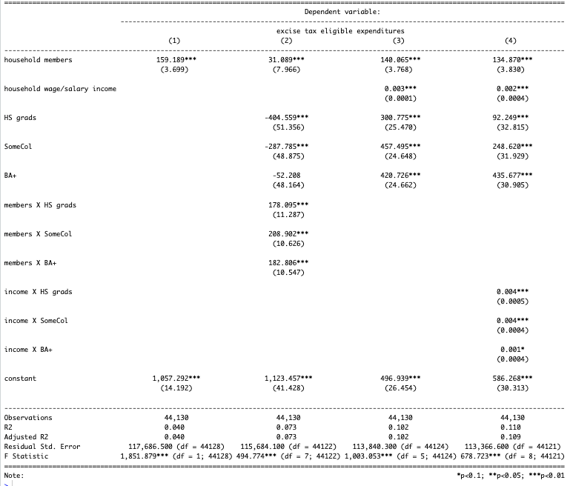

The increase is driven most by gas expenditures, the largest category of expenditures. Table 2 displays the relationship between excise-tax eligible expenditures and household members, broken out by category, with population weights.

**Table 2**

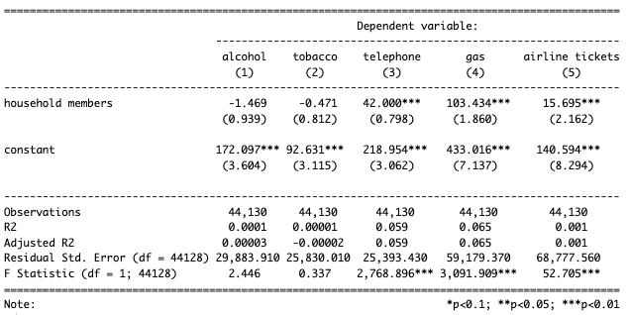

The type of household member matters. Children do not increase costs to the extent that adult members do; as displayed in Table 3. The presence of a child typically decreases expenditure on alcohol, tobacco, and air travel. Gasoline expenditures do increase, to the magnitude of an estimated $66 per family annually. This roughly equates to $3.45 more in excise taxes paid per household, assuming gas is $3.52/gal and applying the tax of $0.184 per gallon.[4]

Note that this exercise does not directly match our methodology; we apportion excise taxes by education and income quintile according to their share of total spending in the CES rather than estimating the tax directly by applying approximate excise tax rates to group average expenditures. But the additional tax contribution from having a child in the house can safely be assumed to be small.

**Table 3**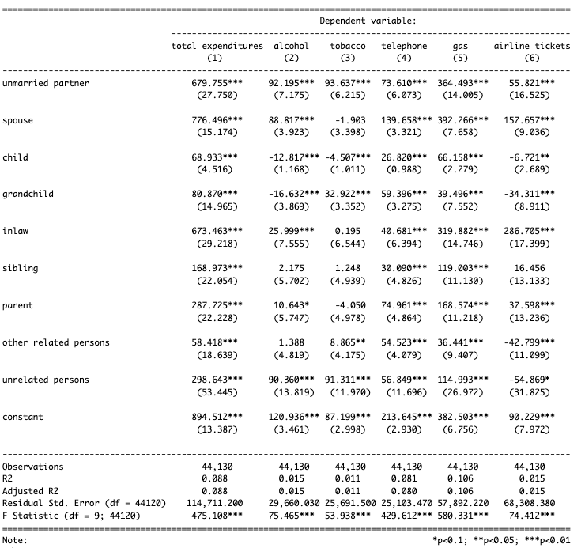

## Expenditures

There are two expenditure models - excluding non eligible and fixed cost U.S. federal expenditure categories, and including all expenditure categories.

For the alternative model, with all expenditures allocated on an average cost basis, an individual H-1B worker without kids pays all costs, including education costs. For the married scenarios, regardless of whether a child is present in the home, pays all costs X2 for the two working parents, including education costs. This is done to be consistent with apportioning education costs to the single H-1B worker.

*See* [*Federal Model/Code/expenditures.R*](https://drive.google.com/file/d/1Cawxhe7jmd9QjPjtITw8mo-TEyg7FbY7/view?usp=drive_link)

*See* [*Federal Model/Supporting Docs/h1b cost method federal estimates*](https://docs.google.com/spreadsheets/u/0/d/1HOZ3lg1AaTYHsgQCY2jG3GOFHUKVpD_z5HQVgCXaoLs/edit) *for the methodology.*

1. Brannon, Ike, and M. Kevin McGee. “Repealing H-4 Visa Work Authorization: A Cost-Benefit Analysis." Available at SSRN 3349786 (2019). The authors find that H1-B spouses earn roughly 78% of the H1-B holder’s income
2. See the IRS’s non-residency rules [here](https://www.irs.gov/individuals/international-taxpayers/nonresident-figuring-your-tax)
3. See the IRS’s substantial presence test requirements [here](https://www.irs.gov/individuals/international-taxpayers/substantial-presence-test)
4. [U.S. Energy Information Administration](https://www.eia.gov/todayinenergy/detail.php?id=61162#:~:text=The%20U.S.%20retail%20price%20for,at%20the%20end%20of%202023.) reports average gas prices to be $3.52 in 2023.